Bengisu Münteha Koç

21801974

EEE 419 – 01

13.11.2024

**EEE 419 Power Electronics Project: Flyback Converter**

**Introduction**

The objective of this project is to design a DC-DC flyback converter using MC34063A which converts the 12V input voltage to 25V output voltage.

Flyback converter is a type of DC-DC converter which operates in periodic steady state (PSS). It is used in applications where electrical isolation between input and output is needed. It can step up or down the input voltage. The simple schematic of flyback converter is shown in Figure 1.

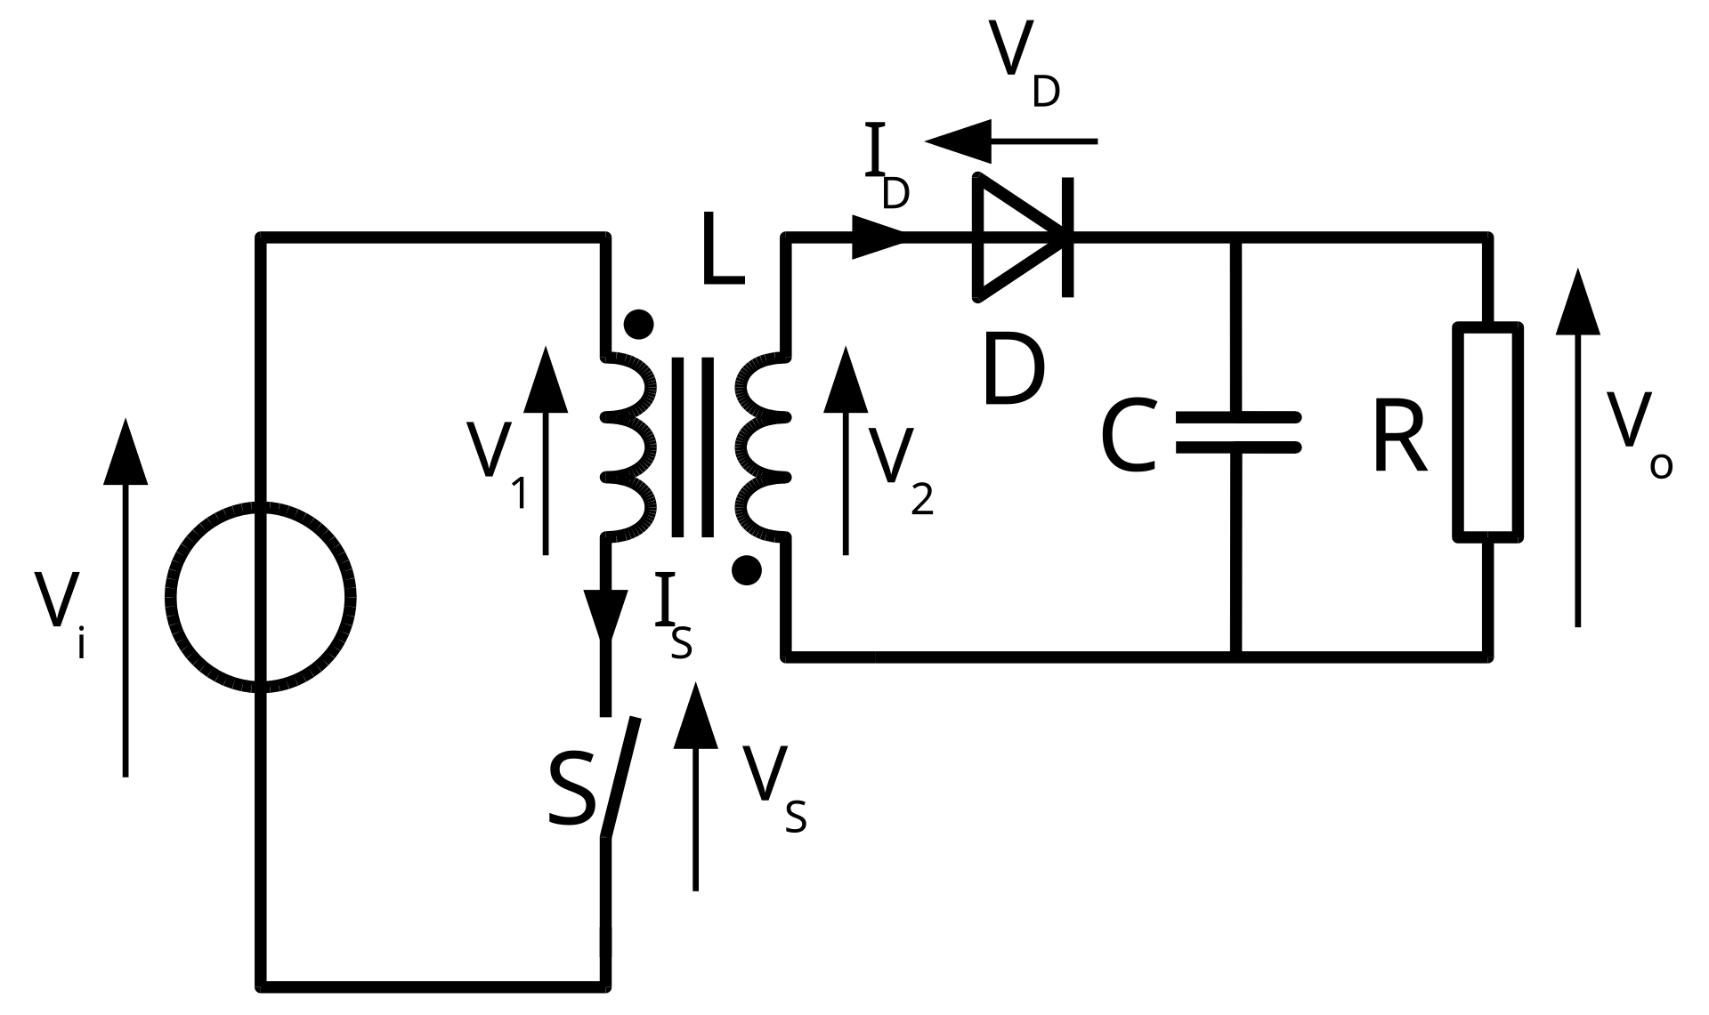

**Figure 1:** Simple Schematic of Flyback Converter [1]

The flyback converter functions by utilizing a transformer to store and transfer energy in a pulsed manner, enabling electrical isolation and versatile voltage conversion. In the "on" state, a switch (typically a transistor) closes, allowing current to flow through the primary winding of the transformer. This current flow generates a magnetic field, which stores energy within the transformer core. When the switch opens (the "off" state), the magnetic field collapses, inducing a voltage in the secondary winding in the opposite direction. This induced voltage causes current to flow through a diode to the output capacitor and load, releasing the stored energy. By controlling the duty cycle of the switch, the flyback converter maintains a regulated output voltage, which can be either higher or lower than the input voltage. The converter operates efficiently in both continuous and discontinuous modes, depending on the load requirements and design configuration.

The MC34063A is a monolithic integrated circuit designed for use in DC-DC converter applications, providing essential functions for efficient power regulation. This IC supports three main configurations: step-down (buck), step-up (boost), and inverting, enabling it to convert a DC input voltage to a different DC output voltage. The MC34063A is notable for its wide input voltage range (from 3V to 40V) and is capable of delivering up to 1.5A of peak current through its internal switch. For applications requiring higher current, an external transistor can be added.

The MC34063A integrates several key components, including an oscillator, a voltage reference, a comparator, a current limit, and an internal switching transistor. This integration reduces the need for external components, making it cost-effective and compact. Additionally, the switching frequency is adjustable up to 100 kHz, allowing flexibility in optimizing efficiency and controlling output ripple.

The MC34063A is widely used in various applications, such as power supplies for portable devices, battery-powered equipment, and automotive electronics, where reliable and adjustable DC-DC conversion is required. Its compact design, efficiency, and versatility make it an ideal choice for student projects and commercial applications alike.

The circuit employed in this project is illustrated in Figure 2.

diyagram, metin, plan, teknik çizim içeren bir resim

Açıklama otomatik olarak oluşturuldu

**Figure 2:** Schematic Blueprint of Flyback Converter

**Design and Measurements**

Desing of the flyback converter is conducted with following steps:

* TS is chosen as 9µs. This is the switching period of the converter.
* Since ipeak is given as 1.1A, RSC is calculated as
* βmin  is equal to 50 according to the datasheet of the MC34063A. RC is used to supply sufficient base current for the switching transistor of MC34063A. The resistance is calculated as

Where Vd is input voltage, 12V. The value of this resistance is set to 330Ω to ease the implementation of the design.

* The sum of the input and Zener diode voltage should be equal to the 35V, since the maximum allowed switch voltage of the IC is 40V. Hence the Zener diode voltage is calculated as 23V.
* VOR is chosen as 9V. This value represents the reflected output voltage in the flyback converter. The voltage appears on the primary side of the transformer when energy is transferred from the primary winding to the secondary winding.
* The coupling coefficient is given as k = 0.9. This value represents the values of the Snubber network.
* The value of [D+Δ2] is chosen as 0.9. This value represents a combined duty cycle factor for ensuring discontinuous mode operation in the converter. Which means that the current fully discharges each cycle and helps maximize power output and stability.
* Duty cycle of the converter is calculated as
* ∆1 value is found with the formula

The values LL and LM represent the inductor values of the snubber network. The equivalents of these values are

Hence the value of is found as 0.0601.

* The inductance of the primary is found as
* The turns-ratio is found as
* The inductance of the secondary is found as
* The number of the turns of the primary is found as
* The number of turns of the secondary is found as
* The off time of the switch is calculated as
* The value of the timing capacitor CT is found from the graph shown in Figure 3. The approximate value of the capacitor is found as 2.7nF. This value may need to change after the simulation.

metin, çizgi, öykü gelişim çizgisi; kumpas; grafiğini çıkarma, diyagram içeren bir resim

Açıklama otomatik olarak oluşturuldu

**Figure 3:** Graph of the Timing Capacitor Capacitance

* RT value is given as 1MΩ. This resistance will not be used for implementation.
* The values of the resistances R1 and R2 are calculated as

This is the reference voltage of the shunt regulator. Since R1 + R2 is in the range of 50K and 150K, the values are determined as R1 = 10KΩ and R2 = 90KΩ. In the implementation part, instead of 90KΩ, 82KΩ will be used with a 10KΩ trimpot.

* Output capacitor value is chosen as 1µF as recommended. In the implementation, this value will be increased.
* RD value is set to 680Ω to limit the current through the photodiode.
* R3 value is set to 10KΩ to bypass the off-current of TL431.
* CD value is set to 10nF to AC couple the cathode and feedback pins of TL431 for proper operation.
* L3 value is set to 10µH to speed up the simulation. This inductor will be short circuited in implementation.
* RB value is set to 220K to speed up the turn-off transient of the phototransistor.
* R4 and R5 values are determined as

Hence the values are chosen as R4 = 2.2KΩ and R5 = 22KΩ.

* The value of R6 is chosen as 3.3KΩ to limit the current of the phototransistor.
* Load resistance value will be determined with simulation results.
* To find the maximum theoretical output power of the converter, the output current is found as

Which is found to be 0.0864A, hence the output power is found to be 2.16W.

* The load resistance value is determined with simulation tests and found to be 500Ω.
* The value of timing capacitor is decreased to 680pF shorten the idle period.
* The final version of the circuit is shown in Figure 4.

metin, diyagram, plan, çizgi içeren bir resim

Açıklama otomatik olarak oluşturuldu

**Figure 4:** Flyback Converter Circuit

**Simulation and Results**

The output voltage startup transient of 12V to 25V converter is shown in Figure 5 with an output capacitor of 1µF and a load resistor of 500Ω. The output value of the converter is observed as 25.85V, which satisfies the required output voltage.

metin, ekran görüntüsü, öykü gelişim çizgisi; kumpas; grafiğini çıkarma, sayı, numara içeren bir resim

Açıklama otomatik olarak oluşturuldu

**Figure 5:** Output Voltage of Flyback Converter

The average output and input power is found through LTSpice as shown in Figure 6 and Figure 7, respectively.

metin, ekran görüntüsü, yazı tipi, çizgi içeren bir resim

Açıklama otomatik olarak oluşturuldu

**Figure 6:** Average Value of Output Power

metin, ekran görüntüsü, yazı tipi, çizgi içeren bir resim

Açıklama otomatik olarak oluşturuldu

**Figure 7:** Average Value of Input Power

Hence the efficiency of the converter is calculated as 55.2%.

The zoomed-in version of the output voltage for one ripple period is shown in Figure 8. The ripple voltage value of the converter is shown in Figure 9.

metin, öykü gelişim çizgisi; kumpas; grafiğini çıkarma, çizgi, diyagram içeren bir resim

Açıklama otomatik olarak oluşturuldu

**Figure 8:** Output Voltage for One Ripple Period

metin, ekran görüntüsü, yazı tipi, sayı, numara içeren bir resim

Açıklama otomatik olarak oluşturuldu

**Figure 9:** The Ripple Voltage Value

This simulated ripple voltage can be reduced by implementing larger output capacitor.

The switch voltage at pin1 with Vd = 12V and VOR = 9V is shown in Figure 10.

metin, çizgi, öykü gelişim çizgisi; kumpas; grafiğini çıkarma, ekran görüntüsü içeren bir resim

Açıklama otomatik olarak oluşturuldu

**Figure 10:** The Switch Voltage

The period of the converter is shown in Figure 11.

metin, ekran görüntüsü, yazı tipi, sayı, numara içeren bir resim

Açıklama otomatik olarak oluşturuldu

**Figure 11:** Period of the Converter

metin, ekran görüntüsü, yazı tipi, sayı, numara içeren bir resim

Açıklama otomatik olarak oluşturuldu

**Figure 12:** TOFF Value of the Converter

These time values are quite close to the calculated values hence the value of the timing capacitor which is found by trial-and-error method is assumed to be correct.

Switch ON time is shown in Figure 13.

metin, ekran görüntüsü, yazı tipi, sayı, numara içeren bir resim

Açıklama otomatik olarak oluşturuldu

**Figure 13:** Switch ON Time Value

Transformer Implementation

For the implementation of the transformer E core E19 is used. Since the number of turns of the primary is found approximately 15, the inductor is wound, and the value of the inductor is measured as shown in figure 14.

metin, ofis malzemesi, ofis ekipmanı, iç mekan içeren bir resim

Açıklama otomatik olarak oluşturuldu

**Figure 14:** Inductance Value of the Primary at 100kHz

As shown above, the inductance value is quite close to the simulation value which is approximately 38µH.

The value of the series resistance of the inductor is shown in figure 15.

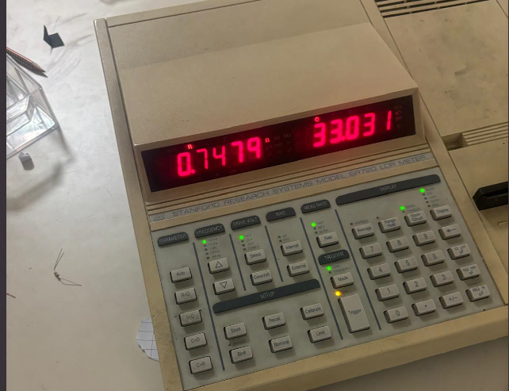

Figure 15: Series Resistance Value of the Primary

The value of the inductance of the secondary is shown in figure 16. As shown in the figure the found inductance is quite close to the one used in the simulation which is 292µH.

metin, ofis malzemesi, iç mekan, ofis ekipmanı içeren bir resim

Açıklama otomatik olarak oluşturuldu

**Figure 16:** Inductance Value of the Secondary at 100kHz

The series resistance value of the secondary is shown in figure 17.

iç mekan, metin, saat, elektronik donanım içeren bir resim

Açıklama otomatik olarak oluşturuldu

**Figure 17:** Series Resistance Value of the Secondary

The mutual inductance of the transformer is found as 91.7µH. Hence the coupling coefficient is calculated as

Hence the experimental value of the coupling coefficient formula is found.

**Conclusion**

In conclusion, the design and analysis of the flyback converter’s key components, including the primary and secondary inductance calculations, transformer winding, and component selection, have been successfully completed. The primary design objectives, such as achieving the target output voltage and maintaining discontinuous mode operation, guided the choice of parameters like the turns ratio, duty cycle, and switching period. Initial measurements of the transformer’s inductance, series resistance, and coupling coefficient confirm that the design meets the theoretical specifications, providing a solid foundation for subsequent stages. This groundwork paves the way for PCB design and practical implementation, with the expectation that further optimization and testing will enhance the converter’s efficiency and stability in real-world conditions.

**References**

[1] "Flyback converter," *Wikipedia*, Oct. 19, 2023. [Online]. Available: <https://en.wikipedia.org/wiki/Flyback_converter>. [Accessed: Nov. 12, 2024].